Structured Independent Learning

This paper is a description of the Structured Independent Learning (SIL) practice that I used for over twenty years of teaching high school students. Following a narrative of how I “discovered” and developed the SIL approach I describe the basics of SIL and how it looks in the classroom on a day-to-day basis. Then I describe the many advantages of an SIL approach and the feedback that I have received from students, parents and administrators. The final section deals with some guidance on how, if you desire, to make a change in your practice and to provide tips for implementing an independent style of teaching in your practice.

## Origins of Structured Independent Learning

The subject was chemical bonding and I was doing what I had learned to do as a teacher – providing notes and discussion on the blackboard. I paused for a moment and surveyed my students. Although the vast majority had their typical looks of practiced interest and attentiveness, it appeared that no one was really paying much attention. To prove it to myself I slipped in the phrase, “I swallowed a frog last night” part way through a sentence. No one heard it. As I continued to do the lesson I wondered: Who am I doing this lesson for? Really! Who *am* I doing this lesson for?

I put down the chalk and faced the class with what must have been a silly grin on my face. After assuring them that they were not in trouble I described what I had just experienced and asked them for their thoughts. A young woman stated that, while my class notes and discussions were generally quite good, she was having difficulty concentrating on them today. I thanked her and then asked the class if they had any suggestions for how we could change and improve this process of teaching and learning. Silence. Then one brave soul at the back ventured that if I gave them photocopies of my notes along with the assignment they could do it themselves. Many students nodded. Another student stated that she preferred having a discussion led by the teacher. A few students nodded. At that point I paused the class, went to the photocopy room, copied a class set of my lecture notes, returned to the class, and distributed the notes and the assignment for that day. The solution we worked out that day was that I would provide photocopies of my lecture notes and examples along with the assignment, activity or project to every member of the class. We agreed that they could ask me questions at any time to receive further instruction and clarification. In addition, a mini-lecture would be provided – attendance optional. The students who wanted a lecture would move up to the front of the room and those who did not would migrate to the back.

The results were, in my view, incredible. Within a couple of classes, no one wanted a lecture any more. I would do the occasional demonstration as a class, but beyond that I learned to rely on them asking questions when they needed to. The majority of the students worked independently or in small groups. My strong, high achieving students continued to achieve highly. My middling and low achieving students got better results. When I inquired into what was happening for them, they stated that they were able to get the help and attention they needed either from myself or from fellow students. But far and away the most incredible result was the change in the class environment. People were having fun and enjoying themselves in the learning process. Students started making suggestions for how we could improve things further. Could I provide a calendar? If the week’s work was done in four days could they have the fifth day off? Some students worked hard in class, while others did less in class and got their work done at home or during a spare. An incredible experience.

However, while the change in my teaching style may have seemed like a spontaneous event, it was not. There was another teacher in the school Mr. C who had been doing a different type of practice for years and he had learned it from a fellow twenty years before that. Mr. C had a set of prepared lessons, assignments and activities that his students worked through. The students were guided by a set calendar where everyone would write the same quizzes and tests on the prescribed day. The student in my class who suggested I provide notes and the assignment was also taking a course from Mr. C. His suggestion changed my practice.

Mr. C had an office of sorts and he invited me to come and share it with him. Over the next two years he and I had many discussions about what students needed from me and what my role actually was as a teacher. Do students really not need a lecture/lesson from me? How do they learn without me? After many discussions and continued experimentation in my classes, I eventually became convinced that an independent learning environment was superior. Using his lessons and my own notes and ideas, I developed my own set of lessons. By the time Mr. C moved to a different school I was teaching in a fully independent manner.

## Structured independent learning – the basics

On the first day of class the students were asked to read the Structured Independent Learning handout that explained how the course operated (see Appendix A). The basic points of the handout are:

* Every learner is different and unique and would therefore be treated as such.
* In addition to learning the course material, a key goal was for each student to become a self-motivated, self-responsible, independent and self-aware learner.
* It is important that students feel free to communicate; to talk to me about problems and issues and to ask questions.
* The fundamental idea that I follow in my teaching is that genuine learning becomes possible when a student has a genuine question in mind. Without genuine questions originating from within, little of lasting value is being learned.
* The class is a non-coercive environment. Students are free to learn or not learn.
* 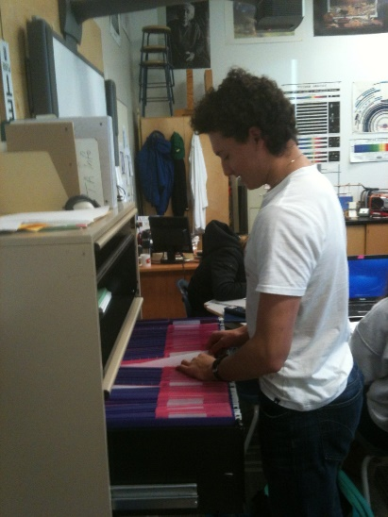Above all, I attempt to clarify that I am not just throwing lessons at them and then they are on their own. I am there to support them in their learning in any way I can.

My classroom was organised in a manner that supported independent learning. At the heart of each course were a set of well prepared and edited lessons that can be found at [www.structuredindependentlearning.com](http://www.structuredindependentlearning.com). The lessons contain the relevant information, examples, lab activities, and problems from which students can learn the course material. While the lessons were provided 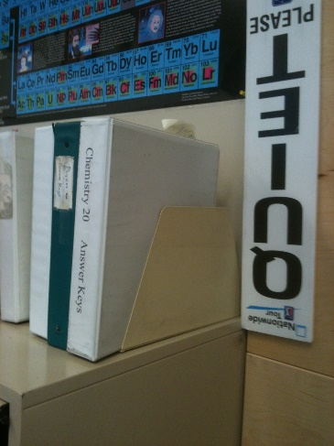on line, there were also file drawers containing paper copies of the lessons and review materials. The students also had access to answer keys that provided fully worked out answers to the practice and assignment problems. Again, these were provided to the students both online and in binders that were available at all times.

Students were also provided with a calendar that indicated when lessons were to be worked on, due dates, quiz dates, and exam days. A partial calendar is given below. Full calendars may be found at my website.

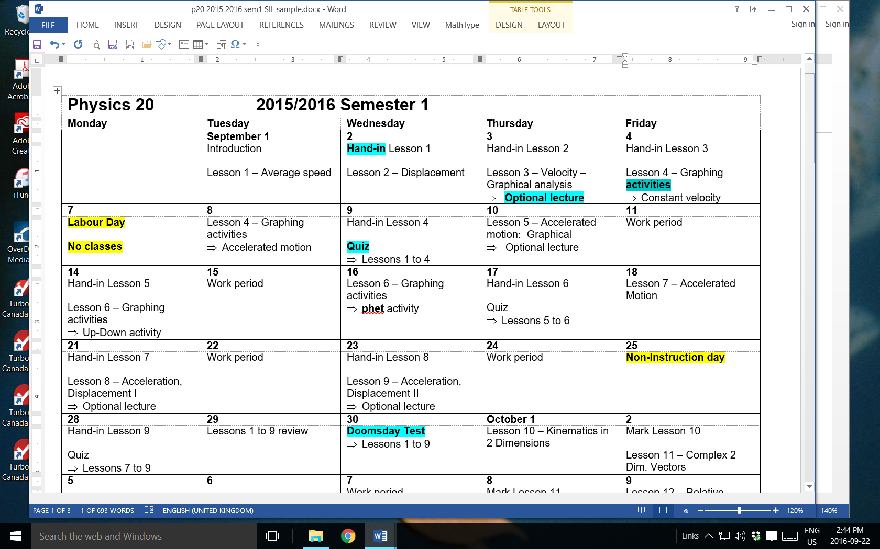

At this point it may be helpful to clarify and discuss a number of items on the calendar. First, the “Hand-in” tag is meant to indicate that students should be finished with a particular lesson by the start or near the middle of the period on that day. When I started with this teaching style, many years ago, I posted the answers on a bulletin board and students were expected to self-correct and hand in the assignments on the indicated day. However, over time it became clear that many students were focussing on being “on time” rather than on the learning. The main goal of having students learn the material by reading and absorbing the lessons, working through the assignments, and asking for help and instruction as required along the way, was being undermined by the need to hand things in “on time.” Eventually I did not have students hand things in. Instead, I would keep an eye on each student and they would receive a 100% completion mark if they demonstrated, via formative and summative assessments, that they understood the material.

Second, for occasional lessons I offered an “optional lecture” for those who wanted one. Again, when I initially used the SIL method I would still provide lectures as I had done before, but with each new class in each semester the number of students attending lectures would quickly dwindle to none. Now, maybe that means I suck as a lecturer, but my students assured me that this was not the case.

Third, several activities were part of each course of study. Students asked for and were provided with materials as they arrive at the activity. Activity write-ups had to be handed in and, in an attempt to make the activity more meaningful and instructive and if time permitted, I would read it as it was handed in and provide immediate feedback while the student was at my desk. This was an excellent way of spotting and discussing errors in understanding with the student. Too often the time lag between handing in the activity write up and marking it resulted in missed opportunities for learning. It also gave the student a chance to correct and resubmit the write up if she desired.

Fourth, note that there were quizzes that students were required to do at regular intervals. Quizzes were designed to provide an in depth look at how well students were understanding the material. Like the lessons themselves, my quizzes went through a series of editions and revisions in order to fine tune their effectiveness in actually testing for what I wanted the students to learn.

Fifth, and finally, the calendar had a series of “Doomsday” tests. The “Doomsday” tag was intended to provoke fear and trepidation in my students ☺. All of the doomsday tests were cumulative from the first day. In my initial teaching practice I had quizzes, unit tests and mid-terms. However, I was unhappy with the resulting piecemeal way that my students were learning the material. The cumulative doomsday tests required that students always had to know all of the material from the beginning of the course to where they were currently at. By the end of the course, students had reviewed the material so often that they knew the majority of the course material in greater depth. Further, they had the opportunity to understand the material as a connected whole and not as a series of unconnected parts.

Another important consideration was the function of the calendar. Was the calendar to be used as a structure that said when things needed to be done? In other words, did everyone in the class write the same quiz, work on an activity, or start a particular lesson on the same day? Several years ago when I worked in more-or-less traditional schools, the calendar was the prescribed structure, but even then I was willing to be flexible. If a few students said that they were not ready for a particular quiz, for example, I tended to have them write a different version of it the next day. I also had students who were away from school for extended periods of time due to health concerns, sport, band, dance, travel, and other individual needs. I would work something out with them to accommodate their needs. The one common structure for all students was that each one had to finish the course in one semester and by the appropriate date. However, when I moved to the National Sport School the demands of the students required far more flexibility. The mandate of NSS was ostensibly for students to be able to participate in elite-level sport and complete their schooling at the same time. Some students were away from school for months at a time due to training, competing and travel. In this context the calendar became less about due dates and more as a guide to let students know what they had to work on. A common occurrence was for a student to found himself to have two months’ worth of work in the last three weeks of the course. The student would be able to plan out the accelerated pace that was required to finish the course on time. However, some students could not finish the course in one semester and would work on it into the next semester and sometimes throughout the year. With the SIL approach I was able to accommodate individual student learning styles and schedules with relative ease and harmony.

## Day-to-day

So what does SIL look like on a day-to-day basis? In my classroom I had classical, jazz or instrumental music softly playing in the background. Students came into class, greeted me and others and then settled down to get to work. There was generally no need to let students know it was time to begin. However, as in all classes there were a few more sociable people who sometimes required a gentle reminder. Students chose to work individually or in small groups. Some would ask to write a quiz or a test.

Being in a non-coercive environment encouraged students to experiment. Doing work and not doing work. Completing a bunch of lessons and then taking a “holiday.” Taking a “holiday” and then doing a bunch of lessons. Asking questions or not. Reading/engaging in the material or not. Skipping to the assignment without reading/absorbing the lesson or the examples. Partial completion of assignments. Some students had to do every assignment problem and do every review problem before they understood it. Other students could do just a handful of questions and have the understanding they wanted. Some students tried to look at the answer key solutions without actually doing the problems themselves. Others would socialise the time away. My role in their experimentation was to let the consequences, both positive and negative, naturally unfold. I would also engage them in conversation about what they were doing: How did that work out for you? If a student was not getting the results he or she desired what could they do to change it? Students soon realised that ownership of their success and the level of that success rested squarely on their shoulders. Mind you, I would also make sure that if a student decided not to work or engage, then she was not allowed to take other students with her. A student could choose not to learn for himself, but he was not allowed to make that decision for someone else.

A crucial feature of the day-to-day practice was the formation and asking of questions. I encouraged my students to ask questions and to seek answers to their questions. My interest in questions was sparked by the educational philosophy of John Dewey. One of his central themes was that when a student had a genuine, authentic question of their own, learning takes place more easily, more efficiently and more deeply. But the question must originate within the student. In the traditional paradigm of education, we teachers decide on what should be of interest to students, the questions that a student should be asking, and the answers they should learn. Teacher derived questions have far less effect than those that originate from within students. In my teaching practice I learned that if I just patiently waited for the questions to arise, a natural and powerful teaching moment was created. If other students did not visibly engage I answered the student’s question on an individual basis. If I knew that several students were in the same place I would go to the white/smart board and answer the question there. Other students could tune in or not. But a common occurrence was that when a student would ask a question about some topic a number of students would lift their heads up from their work and begin to pay attention to the answer. I would then invite the interested students to direct their attention to the white/smart board in the room or to gather around a table where I would provide an explanation. I did not ask the entire class for their attention. I would let people choose to tune in or not.

However, another common occurrence was that as I finished an explanation, another student would ask the same question. This is a common teacher experience – you have just finished an amazing lesson on a particular topic and a student asks about what you have just finished explaining to the class. I learned to not be impatient with this occurrence. In fact, I learned that this was a good thing since it indicated that the student was actually engaged in learning the material. When students were asking a question, they were now ready to hear an answer. Another important aspect of this dynamic was that it demonstrated to the class that I was genuinely interested in their questions even if the same one came up several times in the same class period.

The kind and content of the explanation I would provide depended on the student and the situation. I tried to avoid “canned” or repetitive explanations. Since each student was at a different place in their understanding at any given moment, the explanation I provided was never quite the same from one person to another. As far as I was able I attempted to create fresh, spontaneous answers for that student at that moment. Some students who had a good grasp of a particular concept only needed a little hint in attempting a particular problem. Others required an in depth lesson of the concept or, if their understanding of previous lessons was weak, I would teach backwards and start from the point where they had a solid understanding. Sometimes I would direct the student to another person in the class who I knew had been through that problem already. The idea was that we tend to learn something better when we are asked to teach it to someone else. I would also coach students on how to teach a concept and not just give an easy answer. In this way both students benefitted.

Finally, an overarching theme in my courses was curiosity. It is curiosity and a need to know that provide the sustained motivation to do scientific research of any kind. Why would any person be willing to spend years and decades of effort if there was no curiosity about their research? So I encouraged curiosity, but not necessarily in what I found to be curious. Those with curiosity about a particular topic asked “off topic” questions that often led to interesting discussions. What are black holes? If the universe is expanding, where is the centre? When will we ever use the factoring of trinomials in our lives? I can’t decide what to do after high school. These and other questions led to some of the best class discussions. Sometimes there were students in a class that would ask such questions and sometimes there were not. Each class was different.

## Advantages and disadvantages

There are, in my view, many advantages and relatively few disadvantages to a “guide on the side” approach. Here are some of the advantages:

* Students experience and learn time management and self-responsibility skills. These skills are directly transferrable to their lives in general.
* Students learn independent and interdependent learning skills.
* There was a greater opportunity for conversations with students at a ***meta-learning*** level and to enter into their learning experience. For example, many of my Physics 30 students had a learning method that relied heavily on memorization of individual, unconnected facts and pieces of information. When such a student was experiencing difficulty I would point out their learning mode to them. I could then describe a different more powerful mode of learning that involved learning a principle, like the conservation of momentum, and then applying the principle as a way to problem solve. Rather than memorizing all of the different types of momentum problems, a student could apply one principle and solve any kind of momentum problem with ease.
* Students receive more one-on-one instruction.
* Students could spend time working rather than being part of class lecture/ discussion that they may not require.
* Pacing can be variable. Some students can adopt an accelerated pace and finish a course early. For other students finishing a course in one semester was a barrier to genuine learning. For them a slower pace, over one and a half or two semesters was more effective.
* Relationships with students are more individualised.
* Introverts can be left alone, while extroverts can join in on discussions.
* The “game of school” can be recognised and challenged. The game of school is where students take a course and treat it solely as an exercise in receiving a desired final mark. Opportunities like learning something useful, deeply experiencing a subject, being surprised at what a subject has to offer or other possibilities are not entertained. As my teaching career unfolded I found I had less and less patience for the attitude that a final mark was the only value that a course had. While I tried to stay away from making this an issue that I brought up with every student, I would occasionally voice my concerns with a student who might entertain a different approach to a course of study.
* Several classes can be run at the same time. It was not uncommon to have Math 10c, Physics 20 and Physics 30 students working during the same period. Students often helped each other out and questions from one course often generated discussions that the entire group would participate in.

Some of the disadvantages were:

* There was a period of adjustment to using this approach, but not for my students. I had to learn that the students really did not require a lecture or discussion until they asked for it. I found it difficult to give up the stage and not be the centre of attention. The students taught me that being a “guide on the side” was a superior approach to being a “sage on the stage.”
* Some students have difficulty asking questions. Many students have learned from past experience that questions are generally not well received. Either their former teachers did not really want questions, or teachers had a hard time hearing and answering the question that was actually being asked.
* When the calendar was used as a guide rather than as a more rigid structure, a minority of students experienced difficulty with writing quizzes and tests. They would avoid doing them due to test anxiety and performance issues. I would encourage them that if they had legitimately done their assigned work, they were ready to write the quiz. In some cases I had to insist that he or she write the quiz on a particular day.

## Student experiences

In my experience, the majority of students thrive when given the opportunity. They may require guidance in how to be self-responsible learners, but the true source of their motivation, from within, is allowed to be seen and recognised. There is nothing more powerful to develop self-understanding than for students to develop their own skills at being self-responsible people.

My confidence in my teaching stems from the feedback I received from my students. First, in diploma courses their achievement scores continued to be significantly above the provincial average. Second, the rate of students dropping my classes was quite low. Third, and most significantly, were the responses I received from my students. The last question on the final test at the end of each course asked the students to write a paragraph or two in response to the following question:

People learn different things in different courses depending on both the interests, aptitudes and attitudes of the student and on what the teacher brings to the course of study. **What did you learn that was valuable to you in this course?** Your response does not have to be about course content or anything else in particular. Your response can be personal, or not, but your response should include a reason or explanation. In addition, your response is your response and should not necessarily be written for my benefit.

The majority commented on how they grew personally in addition to learning the course material. Some typical responses were:

This course is unique in the way it is designed. The independent learning style has many advantages for me. I can work at my own pace and I always know what I should be doing. The things I have gotten out of this course won’t only be a broader knowledge of physics, but it has taught me time management and working skills that most courses cannot build. The flexibility offered in this course added to my learning experience and helped me in learning the course material. I think this class is the best learning environment in the school as you actually learn skills you will use out of school. (Cody, grade 12)

As you know, at the beginning of the course I was sort of sitting on the fence trying to decide whether to stay in this class or not. I am glad that I made the choice to stay. I have learned good study habits including time management, study skills, reading skills, question asking skills, and I learned to motivate myself. I think this course has prepared me well for the learning challenges in university and beyond. I also learned some cool physics stuff too! (Breanne, grade 12)

In this course I had a lot of fun. It was my favourite course all year. I believe it was because I had more freedom than in any other class. On top of that though, I learned to take responsibility for my own learning more than in any other class before. I also learned to use the teacher as a resource more than depending on the teacher to teach me everything. Learning on my own like this was exceptionally valuable to me because I learned to take more responsibility and to help me prepare for the real world where there will not be anybody to teach me anything about everything. (Michael, grade 11)

Many students also reported that they experimented with doing work and not doing work. They found that there was a direct correlation between their efforts and their performance. Moreover, they appreciated the opportunity to be able to experiment without a teacher “ragging” on them.

## Push back?

A common question I get is: How much push back did you get from administrators, parents and students? When I first started implementing an independent approach it was, as I stated above, in response to what the students wanted. I honestly did not consider asking my administrative team or anyone else if I could or should do it. It was an experiment. When it worked and no one complained I was assured that it was a good way to go. My administrative team actually had no idea of what I was doing for the first three or four years, mind you at the time I worked in a school with 2700 students and over 150 staff members so it was pretty easy to fly under the radar. When an administrator came at my request to one of my classes to assess my teaching, the students proceeded to extol my virtues. They told him that despite not looking like I was doing very much, they were actually learning quite a bit. Likewise, the response from parents was overwhelmingly positive. For a couple of years, in the spirit of experimentation, I had my students take home the SIL student handout to have it signed and for parents to make comments. Not a problem. In fact, many parents stated that they appreciated that the method did not spoon feed their son or daughter. However, the main source of any push back came from a handful of advanced placement physics students. A minority of these students wanted the regular lecture-style classroom environment and were vociferously put out by an independent style. Why? Because they were good at and felt at home within the traditional paradigm. Similarly, those who thrived the most in this environment were students in non-academic courses. Why? Because they were not very good at the traditional way that school is done. They appreciated not having to sit through a lecture every day and that it was their choice whether they worked or not.

## Making the change

If you are satisfied with your current practice then leave it alone. However, if you are dissatisfied and want to make some changes, the first thing I would recommend is that you open up a frank and honest dialogue with your students. Ask your students what they require of you and listen to the answers. Further, be willing to respond to what they have to say. An alternative would be to propose to your students that you want to try an independent learning approach and that you heard about it from this crazy guy who claims that it works really well. Then see what happens.

When working with teachers who are interested in an independent approach, I have found three major obstacles. First, teachers are very unwilling to relinquish any control of their classroom. The need for feeling that you are in full charge of a group of students should not be underestimated. In the SIL approach, you are actually still in control of the class, but it looks different. You still monitor and correct behavior, but you let students decide if they wish to work or not. You let a student decide what she wishes to do, but she is not allowed to decide for another student. When the SIL approach is working well, the class runs itself. The second bugaboo is that teachers do not want to give up being on stage. For many of us, including me, it feels great to be in front of a class and do your practiced and honed teacher shtick. But the results in my classrooms demonstrated to me again and again that I was not needed as the sage on the stage. I was far more effective as the guide on the side. Sure I still performed when I would demonstrate the law of resonance or set off the thermite reaction or showed how the cosine law becomes the Pythagorean equation when applied to a right triangle. I did not let go of the stage entirely, but I tried to let the students take the stage while I watched from the side. The third obstacle is learning to trust that students will find their own path. In conversations with students over the years, they know that they are ultimately responsible for their own behavior and learning. A teacher can be of great benefit and a great detriment in the process, but the learning ultimately rests with the student. I urge you to let your students experiment, succeed, and fail. The great majority figure it out. You can be of greatest benefit to them by believing that they will be all right in the end.

## Tips for implementation

Start small. There is no need to shift your entire practice to a full on independent model. Use it for one unit and see what you and your students think. Just make sure that your materials are prepared and organized in a manner that students can readily access. Nothing kills momentum faster than when the students are ready to move on and you are not ready for them.

You should by all means use the lessons that I developed, but I strongly suggest that you use them as your starting point. The lessons I developed went through numerous rewrites and editions to become what they are now. However, these lessons worked well for me with my students in my classroom. Your approach, what you value and think is important to teach your students, is inherently different from mine. Therefore, I urge you to edit and change the lessons so that your students can learn more easily from them.

Here are a few suggestions when writing lessons for a new course. First, use as few words as possible. In my experience I have found that textbook writers tend to add mounds of details and interesting side notes, which is fine in its own way, but the central message of the text is often lost in the relatively minor details. In my lessons I tried to get to the point of the lesson as quickly and clearly as possible. Second, use language that explains. Write the lesson in English rather than in Physlish or Mathlish or Chemlish. Avoid using the jargon of a particular subject without thoroughly introducing students to the vocabulary involved. Third, break up the course work into small sized pieces. For example, when I first wrote my lessons for mechanical waves it was a thick booklet of notes with a huge assignment at the end. Even though I explained that the students had more than a week to do the work, many of them found it to be too daunting. Some of them looked at it and did not even start. When I broke it up into four lessons the following semester, with profuse apologies to the first group, the students handled the lessons with ease. Finally, students must be able to enter each new lesson with confidence. Each of my courses, especially Physics 20, start with material that is very simple and basic. The idea is to steadily build the students’ confidence in their ability to attempt and understand the course material. Starting off with difficult material undermines their willingness to try.

Overall, the main idea that I am advocating is for teachers to be reflective in their practice, both within themselves and with their students. I found myself constantly asking what and who my actions were serving. When I used to have a lecture/class discussion style of teaching, for example, it became apparent to me that much of what I was doing was for my comfort and security and not for the benefit of my students. A traditional lecture style is what people (i.e. teachers, students, parents) expect teaching to look like. Everyone knows how it works and how to fit into it. I seriously questioned what I was doing and I was willing to experiment with a number of different ideas. I strongly recommend that you experiment as well.

## Final thoughts

Structured independent learning can transform the teaching experience into a cooperative and meaningful experience. It empowers people and gives them agency in a conscious and open fashion. Students have the opportunity to become **aware** that they are self-responsible beings. People can have great success and people can also experience failure. I monitor what students are doing and when it is evident whether a person is experiencing difficulty due to the course material or if he or she has decided not to work. For those who want and need help, I am there for them. However, for those who decide not to work, I will with kindness and non-interference, let them sink or swim on their own. In any case, the students can take credit for their own successes and failures. It is not the teacher that gets the credit for how well they did in the course. I want them to learn to outgrow their dependence on a teacher. The goal for students to become independent and inter-dependent learners is, in my view, a hugely important part of learning to be a human being who is responsible for his/her actions.

Structured independent learning is something that I have developed through years of reflective teaching practice. It works for me because I firmly know that it works for my students. It is not what every teacher should embrace and do in their practice. Many teachers do wonderful and meaningful work with students within a more “traditional” paradigm. I am advocating that teachers be reflective in their practice. If a particular way of doing things works for the teacher, students and other interested people, then by all means continue such practice. If, however, there are parts of one’s practice that does not work and is detrimental or hurtful to students, then such practice should and ought to be challenged and changed. If you really want to know about your practice, have the courage to ask your students, listen to what they have to say, and be willing to change your practice in response to what they have to say. Students respond to teaching that embodies authenticity, integrity and love.

Appendix A

Structured Independent Learning

I have spent over two decades teaching high school science and math courses in a variety of ways from traditional teacher-centered classes, to computer-based instruction, to approaches where students were completely independent. I have, to the best of my ability, provided the appropriate materials, instruction and structure to help students succeed. However, the success of these approaches has, in my experience, been largely dependent on the student. Some students learn well on their own, some want a teacher to provide notes and lectures, while others enjoy a combination of independence and teacher direction. Some students have been willing to ask questions, even at the risk of sounding stupid, while others have not spoken a single word to me throughout the course. Some students do every problem, read every line, and take down every note, while others have done as little as humanly possible. Some can see a concept and know it forever after, while others never quite get the idea. In short, ***every learner is different and unique***.

Having made this discovery I have endeavored to provide courses that allow every student, as far as possible, to choose the manner in which he or she wishes to learn. My courses are structured so that every student can learn in a manner that best suits the individual. In addition, my courses are designed to teach students to become self-motivated, self-responsible, independent and self-aware learners. In a larger context, beyond school, once an individual knows how to learn for him or her self all things become possible. This course format provides you with an opportunity to become a self-motivated, self-responsible, independent and self-aware learner. As in all things, one learns by doing.

At the heart of each course are a set of well prepared and edited lessons. The lessons contain the relevant information, examples, lab activities, and problems from which you can learn the course material. Your task is to:

1. Read each section of the lessons to understand the key concepts involved.
2. Read, work through, study and understand each example problem.
3. Make notes of key ideas and do the practice problems.
4. Do the assigned problems to learn the concepts.
5. If you do not understand something in the lesson, **ask** and I will provide you with a brief explanation, mini-lesson, lecture for the entire lesson – whatever is required.
6. **Ask questions** if you do not understand something. I will always answer your questions to the best of my ability. **Learn to use me as a resource.**
7. Enjoy the learning experience.

I will also occasionally provide demos, video materials and direct you to particular websites that will help to clarify the principles and concepts under discussion. The majority of the instruction is done within the lessons and by **asking me questions** when you do not understand something.

Generating, asking and answering questions is, in my experience, a crucial part of any learning experience. Therefore, the fundamental idea that I follow in my teaching is – **genuine learning becomes possible when a student has a genuine question in mind**. In other words, a student may go through the motions of what looks like learning, but if there are no questions being developed within the student’s mind there is little or no actual learning going on. If you have a question, please ask. I will do my best to (a) hear the question you are asking and (b) answer the question. (Incidentally, if you are very lucky you may stumble upon a truly profound and inspiring question that haunts you for the rest of your life. Those are the questions you really want.)

You will also receive a general **calendar** outlining when lessons ought to be worked on, assignment and activity due dates, quiz dates, and “doomsday” exam days. Given the nature of the students at the National Sport School, it is expected that people will not always be “on time” in following the general calendar. Nevertheless, the calendar provides a structure that students ought to follow in order to successfully complete the course. Barring other factors like training, competitions, etc., the calendar indicates when work on a lesson should be underway and when it should be completed. Since you are given a calendar of everything that will be covered in class on a daily basis, you will know when quizzes and tests are to be written. It is your responsibility to read the calendar. If you know in advance that you will be missing any school days, you should **talk to me**. It is your responsibility to **talk to me** about missed work. In fact, I expect that everyone will have his or her own unique issues which we shall discuss to find viable solutions. I suggest that you endeavor to work with or ahead of the calendar schedule.

Another key principle that I follow is that ***you are responsible for your own learning***. Learning to be responsible for your own learning can be one of life’s most difficult lessons. If you demonstrate through your actions that you can handle the responsibility of working independently, I will be pleased to give you as much freedom as you require. However, if by your actions you demonstrate that you cannot handle the responsibility, I will work with you to help you learn how to be responsible. But, if you decide not to work, I will, with kindness and non-interference, let you sink or swim on your own. Of course, personal situations do arise. If there are extenuating circumstances, **talk to me**. The main objectives are to learn the course material, develop self-responsibility for learning, and to enjoy the entire experience. Further, while it is your choice whether you work or not, I will not tolerate your interference with other students’ efforts to learn. A mature and responsible attitude is expected at all times.

The lessons, answer keys, and review materials may all be found on the D2L website. You may also help yourself to copies of the lessons and review materials that are in the file drawer. Each assignment is accompanied by an answer key and you should feel free to check your solutions at any time. If you do not complete an assignment, activity, quiz or test, a zero will be assessed until you complete the assignment, activity, quiz or test.

I believe it is my job as a teacher to provide the best environment in which learning can take place. If you have any questions or concerns, **talk to me** and bring them to my attention. If you are not learning things effectively, **let me know**. We can work something out. Do not hesitate to **talk to me** about any problems or concerns you may have.

Let us endeavor to make your learning experience in this course the best you have ever experienced.

Dr. Ron Licht